Physical Features of Georgia

Physical Features Impact on Development

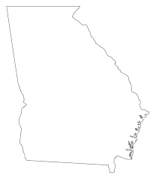

Thesis Statement

The physical features of Georgia impacted its development…

____________________________________________________________

Regions of Georgia

Regions of Georgia Economic Impact



Thesis Statement